**Cyclistic Bike-Share Analysis**

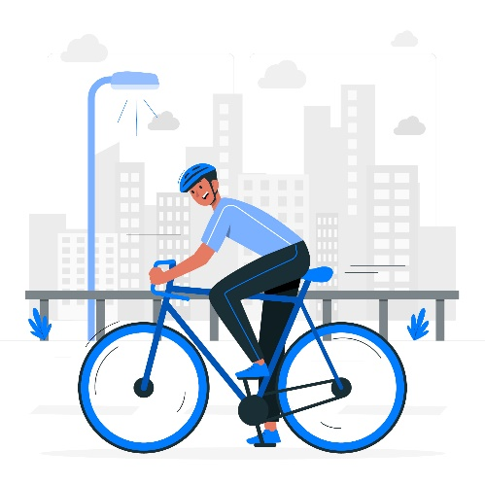

Note : you can download in here [presentations slides](https://docs.google.com/presentation/d/1y_Jbh3Wk0yMSMq34lGYe8xYTYrok0rtV/edit?rtpof=true) and [the coding with R](https://github.com/hananifira/Bike-Share-Analysis/blob/main/bicycle.R)

**Introduction**

Cyclistic Company

Cyclistic is a bike-sharing company in Chicago. Cyclistic maintains more than 5800 bicycles and 600 docking station. This company attracts more customers by offering price flexibility . Although the pricing flexibility helps Cyclistic attract more customers , they also believes that maximizing the numbers of members will be key to the future growth

Problem Statement

maximizing the numbers of Cyclistic members from convert the casual riders into Cyclistic members

Bussiness Task

* How do convert casual riders into cyclistic members?
* How do members and casual riders use Cyclistic bike differently?

**Key Takeaways and Recommendation**

Key Takeaways

* Casual riders mostly use electric bike , Member riders mostly use classic bike for trips
* Casual riders; increase over the time at 4:00 until peak time at 17:00 , Members riders; speak of increase time at 8:00 (going to work) and 17:00(going to home)
* Casual riders mostly trip on the weekend, Member Riders mostly trip on the weekday
* Casual riders active during spring season, Members riders tend to be stable per month

Recommendation

* Introducing plans thats may be more appealing to casuals for the spring months. This marketing should be done during the autumn months in preparation. Promotions and ads during this season could reach substansial amount of riders
* The Weekend Pass is intended for casual riders who use a bikes primarily on the weekends. The Weekend Pass will have lower price point than the Annual Pass(but only on Friday, Saturday, and Sunday)
* Add m ore electric bikes to the inventory since casual riders prefer them over classic bikes
* The per-use balance card membership option might be more appealing to casual riders. Conversely, the current payment structure might be changed to make single-use more expensive for casual riders while also reducing the cost of long-term membership